First, simply add in the image of the tile and assign the material of the tile to Scroll 1 in the prefabs folder, then implement the script into it. After implementing the script, you should see a float input called **Scroll Y**. The number in it is what will to determine how fast the tiles move in a certain direction in the Y axis. If you want, you can duplicate them and move them along the x axis in the editor menu.

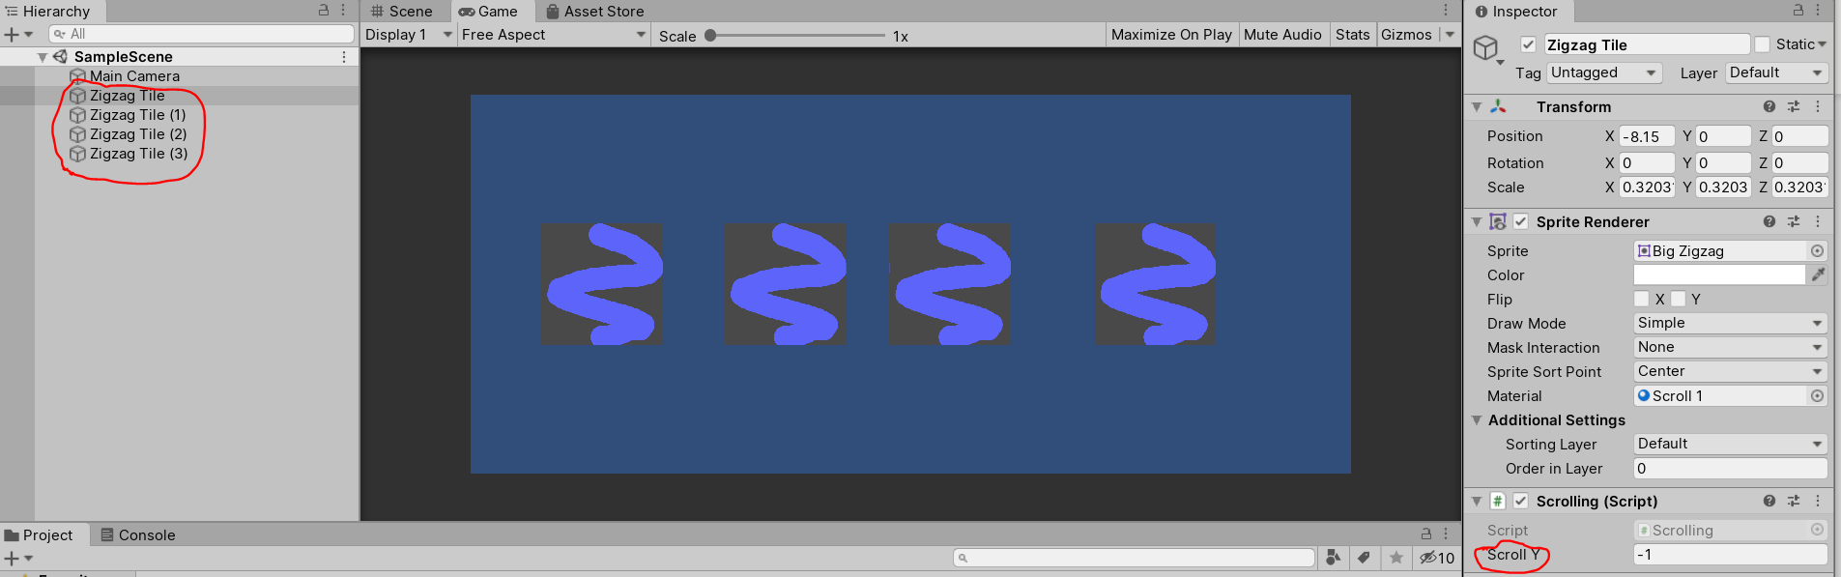

You can edit the **Scroll Y** float number for the amount you duplicated and the higher the number, the faster it will move.

There is a part of the script that will delete any material that is copied as this will interfere with performance and that is not what anyone wants to happen to their powerful computer.